ECE/COE 1896

Senior Design

Spring 2017

Improvement of the Continuous Annealing Line Simulator – CAL

Project Final Report

Instructor: Irvin R. Jones

Mentor: C. Isaac Garcia

Section: Senior Design: Wednesday 1:00-2:50

Prepared By: Kaitlyn Carey

Daniel Figula

Andrew Zundel

Report Grade: ___________

# Table of Contents

**Table of Contents** **3**

**Table of Figures** **5**

**Table of Tables** **5**

**Executive Summary** **6**

**Introduction** **7**

**System Requirements** **7**

Operation of the Lower Furnace Gate 7

Sample passing from lower furnace to cooling area 7

Sample passing from cooling area to lower furnace 7

Increase Quality of Temperature Control 7

Improve Sample Positioning 7

**Design Constraints** **8**

Variable Sample Length 8

Use Existing Control System 8

Sensor Sampling Rate 8

**Conceptual Design** **8**

Gate Design 8

Temperature Sensor Design 8

Positioning System Design 8

Feasibility Analysis: Decision Matrix and Final Design Recommendation 9

**System Risk Management** **11**

**Detailed Design** **11**

**System Test and Verification** **13**

**Operational Concept** **15**

**Use** **15**

**Maintenance** **20**

**Summary** **21**

**Appendix A: Image of the CAL System** **22**

**Appendix B: System Circuit Diagram** **23**

**References** **24**

# Table of Figures

Figure 1: Risk Assessment Diagram 10

# Table of Tables

Table 1: Conceptual Design Decision Matrix 8

# Executive Summary

# The continuous annealing line simulator is a piece of laboratory equipment that is used to anneal advanced high strength steels (AHSS) for the automotive industry. This system is capable to replicate the annealing of strip samples to produce the required microstructures in AHSS. It uses two furnaces for the heat treatment, with a built-in cooling system, and a strip transport system using a stepper motor to move the sample between the areas to anneal it as desired. The control system is implemented on a Raspberry Pi Model B and an Arduino UNO with a user interface constructed in Python.

# This project was the improvement of the continuous annealing line simulator, which involved altering the current system’s control software and circuitry to improve the control of the gate on top of the lower furnace, the positioning of the sample within the system, and measurement of the sample’s temperature within the second furnace. This document contains the requirements, risk assessment, conceptual and detailed design, testing, use, and maintenance involved with completing this project. The gate control and positioning issues with the current system were handled by separating the system into 4 stages: Furnace 1, Cooling, Furnace 2, and Loading. The gate issue made use of a logic system that took the current stage position of the sample and the next stage position of the sample, and if the gate separated the two stages, it was opened to allow the sample to pass through, and remained closed if not. The positioning accuracy was improved by centering the sample within each of the stages, using a stepper motor controlled strip movement. The temperature measurement of the sample within the second furnace was performed using another IR sensor placed outside the furnace and aimed at the sample while inside the furnace.

# The testing of the gate control showed that it opened and allowed the sample to pass through when necessary, and remained closed otherwise. A possible issue arose where the sample was moving through the gate from an adjacent stage, and it nearly collided with the gate as it opened, indicating samples longer than 8 inches or a stepper movement faster than 120 rpm, could result in a collision. The testing of the sample positioning showed that the system was capable of positioning samples of different lengths properly, and within the required 0.25 inches of its desired centered position, as measured using a ruler. The testing of the temperature measurement of the sample while it was within the second furnace was done by heating the sample to different temperatures within furnace 1 and measuring its temperature using the IR sensor positioned in front of furnace 1 and then moving it to furnace 2 to measure its temperature using the IR sensor positioned there for comparison. The testing showed that the temperature measurement was always lower when measured using the second furnace IR sensor, but this was deemed acceptable performance as the sample was considered to be cooled as it was moved between the furnaces.

# Introduction

The continuous annealing line simulator is used to anneal advanced high strength steels (AHSS) for the automotive industry. By making the improvements in gate control, positioning accuracy, and temperature measurement in the second furnace, the simulator will be capable of a greater variety of annealing strip sample treatments to produce microstructures in AHSS. This reports begins with the requirements used to determine the success of the project, progressing into the conceptual designs considered for implementation in the project, then going through a decision matrix and risk assessment to decide on the final design. Next, the final design is described in detail, followed by the testing procedure and results used to verify the requirements were met, with the system’s operational concept. use, and maintenance information provided afterward for anyone who plans to use the continuous annealing line simulator.

# System Requirements

The purpose of this section is to give a detailed description of the requirements contained within the “Continuous Annealing Linear Simulator” software and hardware based optimizations. It will illustrate the purpose and interaction with other components of the system as well as users. This section is primarily intended to highlight the requirements of our design.

## Operation of the Lower Furnace Gate

The CAL simulator shall allow the lower furnaces gate to open and close so the sample can pass into the cooling area or the furnace.

### Sample passing from lower furnace to cooling area

The gate shall open when the sample passes from the lower furnace to the cooling area and then close when the sample is within the cooling area.

### Sample passing from cooling area to lower furnace

The gate shall open when the sample passes from the cooling area to the lower furnace and close once the sample is within the lower furnace.

## Increase Quality of Temperature Control

A third sensor shall be introduced into the system to provide accurate temperature reading of the sample while in the lower furnace.

## Improve Sample Positioning

The CAL simulator software shall track and place the sample position within ¼ inch of its desired physical location.

# Design Constraints

## Variable Sample Length

The sample positioning shall accommodate sample lengths between 1.5 inches and 8 inches.

## Use Existing Control System

The Raspberry Pi microcontroller currently implemented to operate the CAL simulator will be used.

## Sensor Sampling Rate

The third temperature sensor shall sample the temperature of the sample while in the lower furnace at a rate no less than 1 Hz.

# Conceptual Design

## Gate Design

* + 1. **Gate Design 1**

Replace the actuator motors controlling the gate and its associated circuitry and rewrite the code for the new gate actuators to operate as specified.

* + 1. **Gate Design 2**

Use the current system and improve the code logic for the operation of the gate.

## Temperature Sensor Design

* + 1. **Thermocouple Sensor Design**

Install a thermocouple in a fixed position on an automated system to position the thermocouple near the sample for voltage readings. Install circuitry/software to interpret thermocouple voltages as temperature measurements.

* + 1. **IR Sensor Design**

Install a IR temperature sensor to measure the sample temperature with the necessary circuitry and code to read the data from the sensor.

## Positioning System Design

* + 1. **New System Design**

Replace the strip transport system with an alternative method that would be able

to pass through the gates when closed, withstand the temperatures inside the furnaces without embrittlement, and not add strain to the sample. Control circuitry and software would be created to enable the new system.

* + 1. **Calibration Mode Design**

Make use of the existing sample transport system and add a calibration step adjusting the sample position on startup of the system and alter software to better track the sample position during simulations.

## Feasibility Analysis: Decision Matrix and Final Design Recommendation

|  |  |  |  |  |
| --- | --- | --- | --- | --- |
| Solutions | Simulator Down Time (5) | Simulation Improvements (3) | Installation (2) | Fitness Score |
| Gate | Low- Will halt simulations at times during replacement  5 x 1 = 5 | High- Gate operates as desired during simulation  3 x 3 = 9 | Low- Involves installation of a new gate  2 x 1 = 2 | 16 |
| Replace Gate |
| Debug Gate | High- Gate control can be modified and tested without effect on simulation  5 x 3 = 15 | High- Gate operates as desired during simulation  3 x 3 = 9 | High- Utilizes existing system, no installation  2 x 3 = 6 | 30 |
| Position | Low- Positioning system would be completely offline, preventing simulations during installation  5 x 1 = 5 | Moderate- positioning errors of current system will be rectified, may also require some calibration mode  3 x 2 =6 | Moderate- Installation may be beyond our abilities  2 x 2 =4 | 13 |
| New System |
| Calibration Mode | High- Can be performed without disrupting simulations  5 x 3 = 15 | High- Provides accurate sample positioning after startup calibration  3 x 3 = 9 | High- No installation  2 x 3 = 6 | 30 |
| Temperature | High- Simulations will not be disrupted during installation  5 x 3 = 15 | Moderate- Sample temperature data can be collected while in second furnace  3 x 2 = 6 | Moderate- Thermocouple may hinder sample movement  2 x 2 =4 | 25 |
| Thermocouple |
| IR Sensor | High - Simulations will not be disrupted during installation  5 x x3 = 15 | High - Sample temperature data can be collected more accurately  3 x 3 =9 | High - IR sensor can be installed some distance from the sample  2 x 3 = 6 | 30 |

Table 1: Decision matrix table for ECE/COE 1186 Final Report.

The decision matrix above uses three different scaling levels and three decision parameters to define the merits of each design. The three scaling levels are Low, Moderate, and High, with the associated values being 1, 2, and 3, and the greater significance being associated with the higher value. The three parameters Simulator Down Time, Simulation Improvements, and Installation are weighted 5, 3, and 2, accordingly; these weights indicate each parameter’s overall significance in making the design decision, with the higher value corresponding to being more significant. Simulator Down Time indicates the amount of time that the CAL simulator would’ve been unavailable to be used for testing while it was improved during our project. Simulation Improvements corresponded to the positive impacts of choosing one of the proposed designs on how the simulator operated following the completion of the project. The Installation parameter was a measure of the difficulty of the implementation of each design. The Fitness Score is the sum of the products of the scaling levels and each parameters weighted value, with the design having the higher Fitness Score being viewed as the better option.

The first gate design was to replace the current gate system, while the second design was to debug/fix the current gate system. While, replacing the system could’ve been a better option, it would’ve been more expensive, required more simulator down time, and the issues with the current gate system appeared to be easily remedied with changes to the control logic within the code and adjustments to the circuit wiring.

The initial positioning system design of replacing the current system was the lesser design compared to the calibration mode design as it would’ve required the significant down time, more time for research and design to replace a working system, and it would’ve been more expensive, whereas the calibration mode design fixed the issues at a lower cost, in less time, and didn’t require simulator down time.

The use of a thermocouple design for temperature measurements in the second furnace was comparable to implementing an IR sensor, but the thermocouple would’ve required to be in contact with the sample for an accurate temperature reading, possibly hindering the sample’s movement in and out of the furnace, making the IR sensor the better design as it could be distanced from the sample and still have an accurate measurement, even though it was more expensive.

# System Risk Management

Figure 2 depicts the major sources of risk involved with the project.

|  |  |  |  |  |  |  |
| --- | --- | --- | --- | --- | --- | --- |
|  |  | **Consequences** | | | | |
|  |  | **MINIMAL** | **MINOR** | **MODERATE** | **SIGNIFICANT** | **SEVERE** |
|  |  |  |  |  |  |  |
| **Probability of Occurrence (%)** | **Level 5:**  **81-100%** |  |  |  |  |  |
| **Level 4:**  **61-80%** |  | Simulation time overlaps with time we want to work on improvements to the simulator |  |  |  |
| **Level 3:**  **41-60%** |  | Incorrect understanding of existing control circuitry | Unable to develop remotely, due to environmental/hardware constraints | Resources not available in time | Lack of time for solution implementation |
| **Level 2:**  **21-40%** |  | Lack of understanding of existing code base | Complications interfacing with hardware | Break code base interfering with sample testing | Simulator breaks during our design process |
| **Level 1:**  **0-20%** | Poorly written code | Additional funding is unavailable | Member of group drops class | System crash resulting in loss of code base | Misunderstanding customers expectations |

Figure 1: Risk Assessment Diagram

In Figure 2, the risk elements placed in the area of the risk diagram appropriate to their probability of occurrence and their severity of impact. Most notable probable risks include the poorly written code segment. This was mitigated by restructuring and organizing the code base to avoid misunderstanding the code. The resource availability issue is also a notable factor. We mitigated the outcome of this risk by providing the means for a sensor to be introduced to the system at any time and the code shall support the need of the new sensor if configured properly. The remote development was mitigated by the use of another Raspberry Pi that could run the code, but more time was devoted to being in the lab to ensure proper functionality of the code as it was generated.

# Detailed Design

Our system design can be split into three areas of interest. One concerning the gate, another concerning temperature, and a third concerning the positioning system. Other considerations for design was put towards documentation of the control system and its interfacing components.

Initially the project was given no documentation with regards to the control system or the interfacing elements of the system. To prevent confusion further along the process we documented the interfacing components, recorded a sketch of the existing circuitry, and commented and organized the codebase. This ensured that our understanding and the understanding of future groups can properly understand the design of the previous system and the system moving forward.

With regards to gate control improvements we decided to use the pre-existing system to improve the quality and response of the gates movement within a simulation. To do this we used a reading of the systems potentiometer to track movement when reading a voltage difference. This potentiometer is attached to the stepper motor of the system and when the sample is moving creates a voltage difference when reading the voltage at two periods of time. We then broke the system logically into four stages Furnace 1 (the top furnace), Cooling Area, Furnace 2 (the bottom furnace), and Loading. On a call to the stepper motor the current and the next logical stage are noted. With the combination of stages and movement we extract a direction of travel and predict if the gate will need to open for the sample to move between the two stages. This computation of the sample’s movement and direction is done within a thread to ensure the gate opens in an efficient manner.

Considering the temperature control improvements, we decided that a third infrared sensor was the best option for improvements of this system. The third sensor will allow the diversity of sample testing to increase and provide accurate readings of samples within the second furnace. This was done by adding code supporting the reading and converting of data read in as an analog voltage from the IR sensor and converting it to a temperature measurement. Further improvements were made to the user interface to increase the variety of tests that the simulator can support.

With regards to position control improvements, we decided to introduce a calibration element to the system. Inaccuracies in the position of the sample varied due to unpredictable movement of the strip when power to the system is shut off. This created an offset and a lack of tension on the strip making sample position physically inaccurate. We have devised a calibration routine that will ensure that a sample will always be centered in the appropriate location dependent on the sample length. This process has been documented so that future simulations will not have issues with sample position accuracy. The positioning is based on factors of sample length and the four stage positions of the system (Furnace 1, Cooling, Furnace 2, and Loading).

# System Test and Verification

Gate Control Test

The sample was moved between two of the four stages (Furnace 1, Furnace 2, Cooling, and Loading) in all possible combinations where the sample moves, making the sure the gate opens, allowing the sample the pass through, and closing afterward and remaining closed when the sample is not going to move through the gate.

|  |  |  |  |
| --- | --- | --- | --- |
| Initial Position | Ending Position | Expected Outcome | Actual Outcome |
| Loading | Furnace 1 | Gate opens and closes | Gate opened and closed |
| Loading | Cooling | Gate opens and closes | Gate opened and closed |
| Loading | Furnace 2 | Gate remains closed | Gate remained closed |
| Furnace 1 | Cooling | Gate remains closed | Gate remained closed |
| Furnace 1 | Furnace 2 | Gate opens and closes | Gate remained closed |
| Furnace 1 | Loading | Gate opens and closes | Gate opened and closed |
| Cooling | Furnace 1 | Gate remains closed | Gate remained closed |
| Cooling | Furnace 2 | Gate open and closes | Gate opened and closed |
| Cooling | Loading | Gate opens and closes | Gate opened and closed |
| Furnace 2 | Furnace 1 | Gate opens and closes | Gate opened and closed |
| Furnace 2 | Cooling | Gate opens and closes | Gate opened and closed |
| Furnace 2 | Loading | Gate remains closed | Gate remained closed |

This test was performed using the Position Control buttons within the UI. When the sample was moving from Cooling to Furnace 2, or Furnace 2 to Cooling the 8 inch long sample nearly collided with the gate as it opened.

Sample Position Test

The position of the sample’s center was measured, with a ruler, relative to its desired location in each of the four stages (Furnace 1, Furnace 2, Cooling, and Loading) using an 8 inch long sample and a 4 inch long sample, after the calibration step was performed using the 8 inch long sample.

|  |  |  |  |
| --- | --- | --- | --- |
| Sample Length | Desired Position | Expected Outcome | Actual Outcome |
| 8 inches | Furnace 1 | <0.25” from position | <0.1” from position |
| 8 inches | Furnace 2 | <0.25” from position | <0.1” from position |
| 8 inches | Cooling | <0.25” from position | <0.1” from position |
| 8 inches | Loading | <0.25” from position | <0.1” from position |
| 4 inches | Furnace 1 | <0.25” from position | <0.1” from position |
| 4 inches | Furnace 2 | <0.25” from position | <0.1” from position |
| 4 inches | Cooling | <0.25” from position | <0.1” from position |
| 4 inches | Loading | <0.25” from position | <0.1” from position |

This test was successful based on the measurements made using the ruler, meeting the requirements by accommodating the two samples, with the 4 inch sample being the shortest sample available during testing, and positioning them accurately.

Temperature Sensor Test

The temperature of the sample was measured using one of the preexisting IR sensors. The sample was repositioned in front of the third IR sensor and the sample temperature was measured for comparison. This was performed at several temperatures.

|  |  |  |
| --- | --- | --- |
| Desired Sample Temperature | Furnace 1 IR Temperature Measurement | Furnace 2 IR Temperature Measurement |
| 300 | 297.64 | 289.51 |
| 350 | 354.22 | 326.43 |
| 400 | 401.02 | 372.36 |
| 450 | 455.16 | 411.33 |
| 500 | 501.29 | 462.95 |

This test was performed, the results are close to what was expected as the temperature of the sample decreased as the sample was moved through the Cooling area from Furnace 1 to Furnace 2.

# Operational Concept

The CAL simulator can be used by a single operator, anywhere with access to 120 V, 60 Hz electrical power and a pressurized air/gas supply. It is currently located in the University of Pittsburgh’s Ferrous Metallurgy Group’s lab space in room 813, Benedum Hall. The system has no time limitations on how long it can be operated, and only requires the operator to exchange the samples to be tested and reset the simulation cycle parameters to the desired values as necessary. An image of the system is provided in Appendix A for reference.

# Use

To properly install the CAL simulator onto a new system, this system requires a Raspberry Pi, and Arduino Uno. This design and code is restricted to CAL simulator:

1. Download or clone the simulator code from the github repository onto your Raspberry Pi: <https://github.com/karatemanz/cal2.0>
2. Install the dependencies and follow the instructions defined in the outlined within the README.md file from the repository
3. Using the Arduino IDE compile and load the Stepper Motor control code onto your Arduino Uno.
4. Follow the schematic in Appendix B to properly wire the circuitry to the devices for proper operation of the system.
5. Make sure that all system dependencies are connected to the devices as specified (i.e. IR sensors, Furnaces, etc.)

After set-up to properly calibrate the system for use:

1. Before providing power to the Stepper Motor, you must first make sure to rotate the motor wheel so that the strip is tight and there is no slack in the strip. This slack reduces the accuracy of the system severely.
2. Make sure that the sample is secure to the strip and that the sample is inline and flush so that the sample does not get stuck during simulation.
3. Make sure each furnace that you will be using for the simulation is turned on.

Running the application:

1. Turn the Raspberry Pi on
2. Navigate to the installation of the cal simulator
3. Navigate to the /app folder which contains the main simulator file
4. Run the simulator by using: sudo python cal.py
5. This will bring up the system’s user interface

The user interface can be broken into three sections. The leftmost pane focuses on simulation set-up, the middle pane deals with graphing and data output from simulation, and the rightmost panel focuses on manual controls and past simulation importing and the viewing of plots from past simulations. The following outlines usage of the user interface with figures:

1. Open Terminal

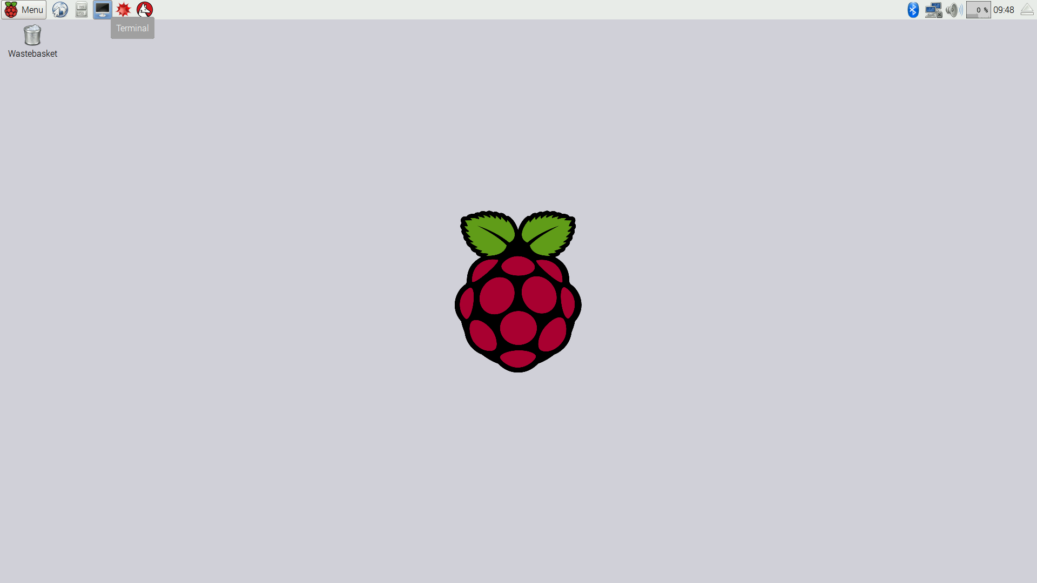

1. Navigate to the cal.py directory within cal2.0

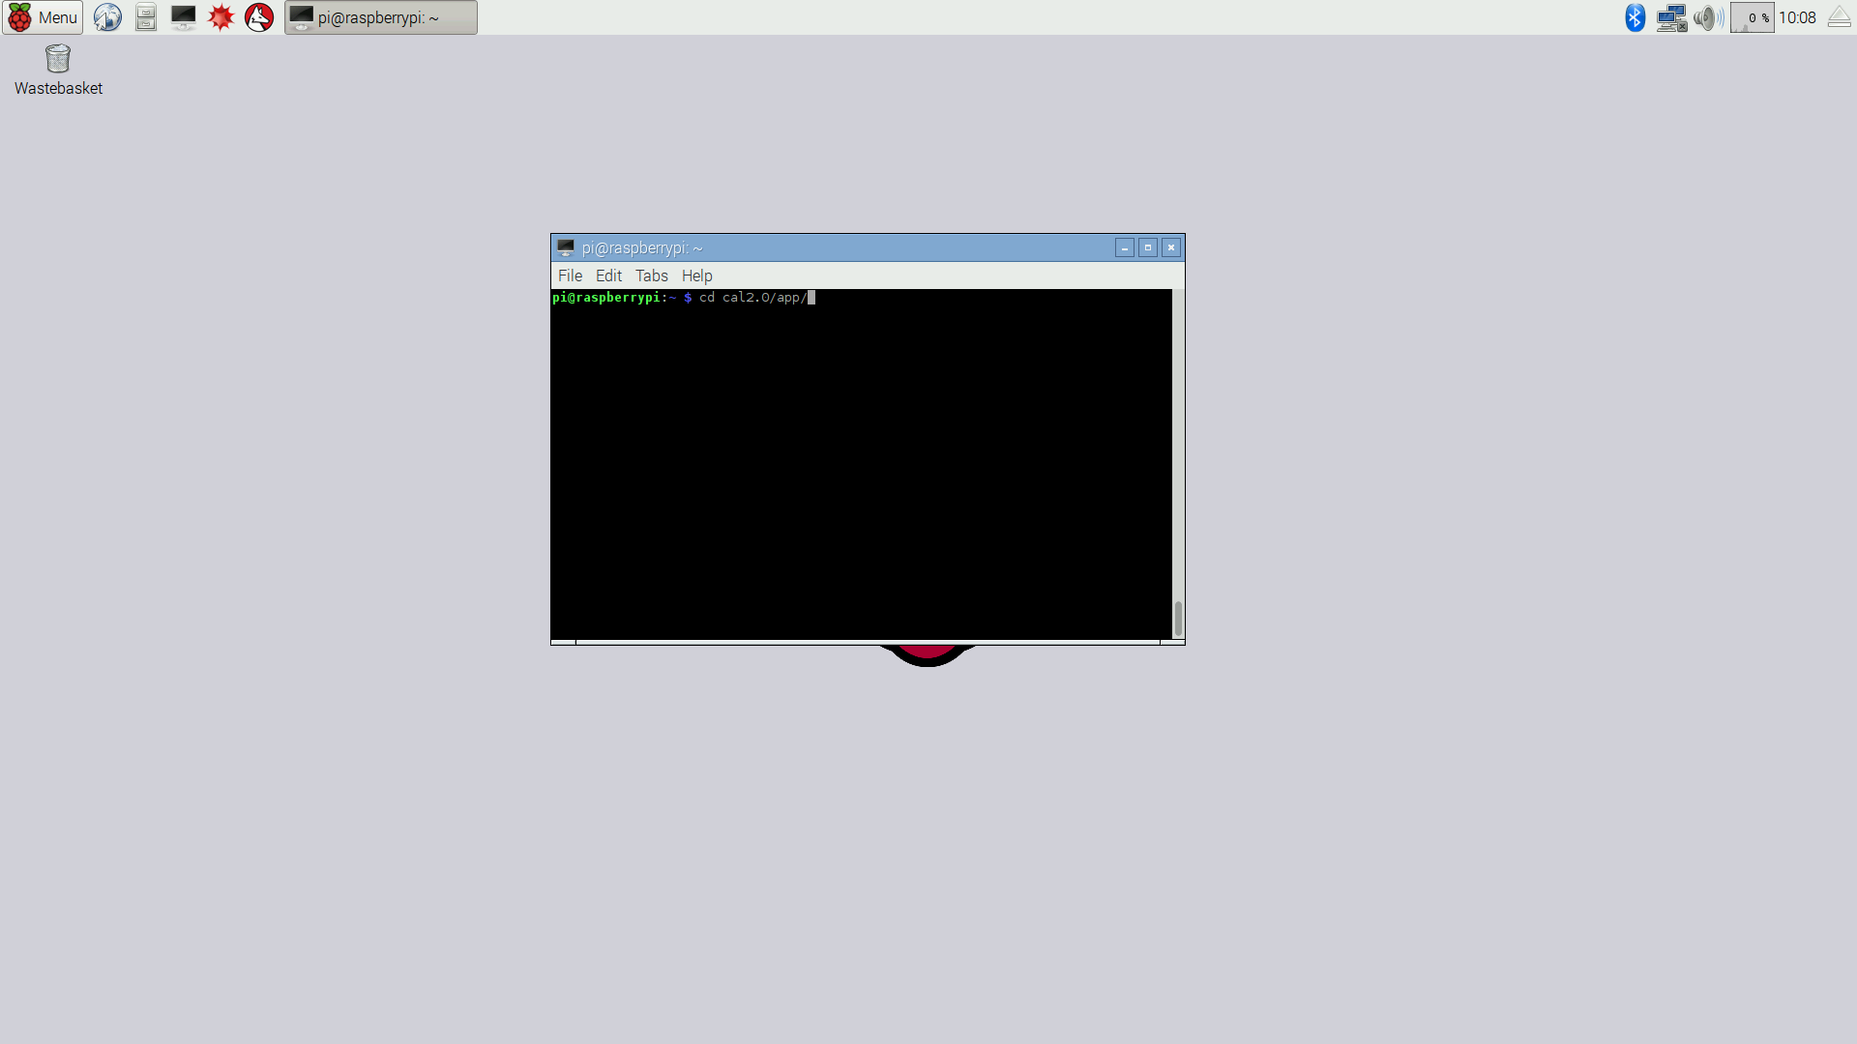

1. Run the application with: sudo python cal.py

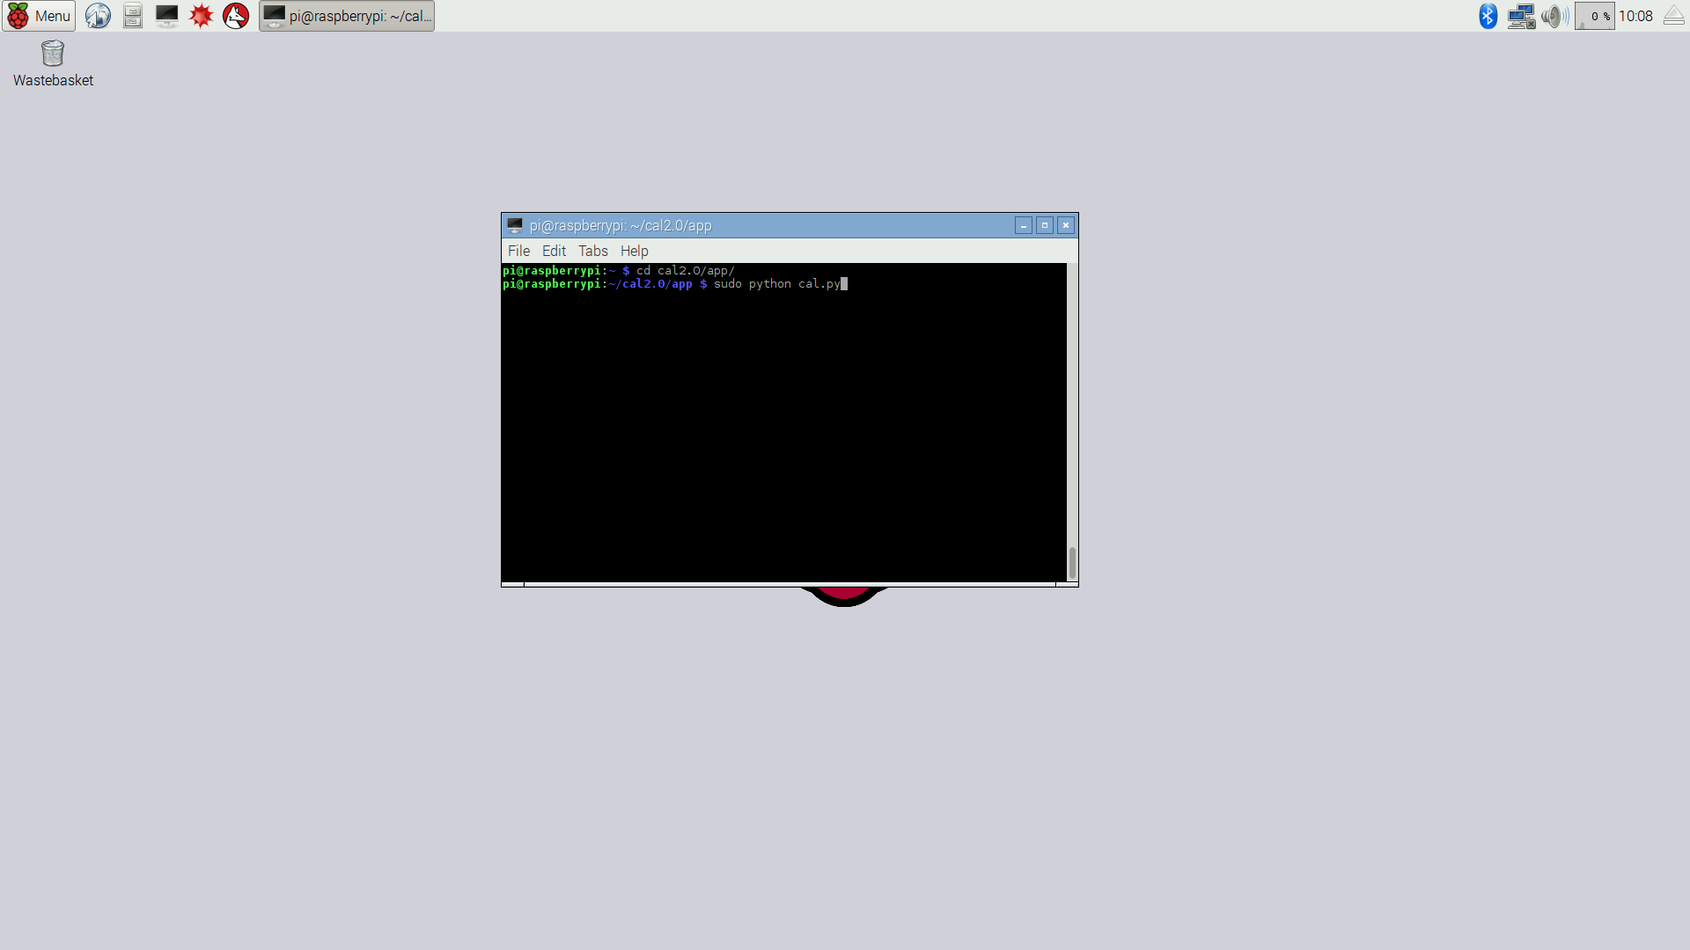

1. To start a new simulation first look at the simulation panel (the leftmost panel) and fine the “Add”, “Remove”, and “Update Buttons”:
   1. Add - Adds a new set-point to your simulation
   2. Remove - Removes the last set-point in your simulation
   3. Update - Updates the graph with a small preview of the data that should be produced by your simulation

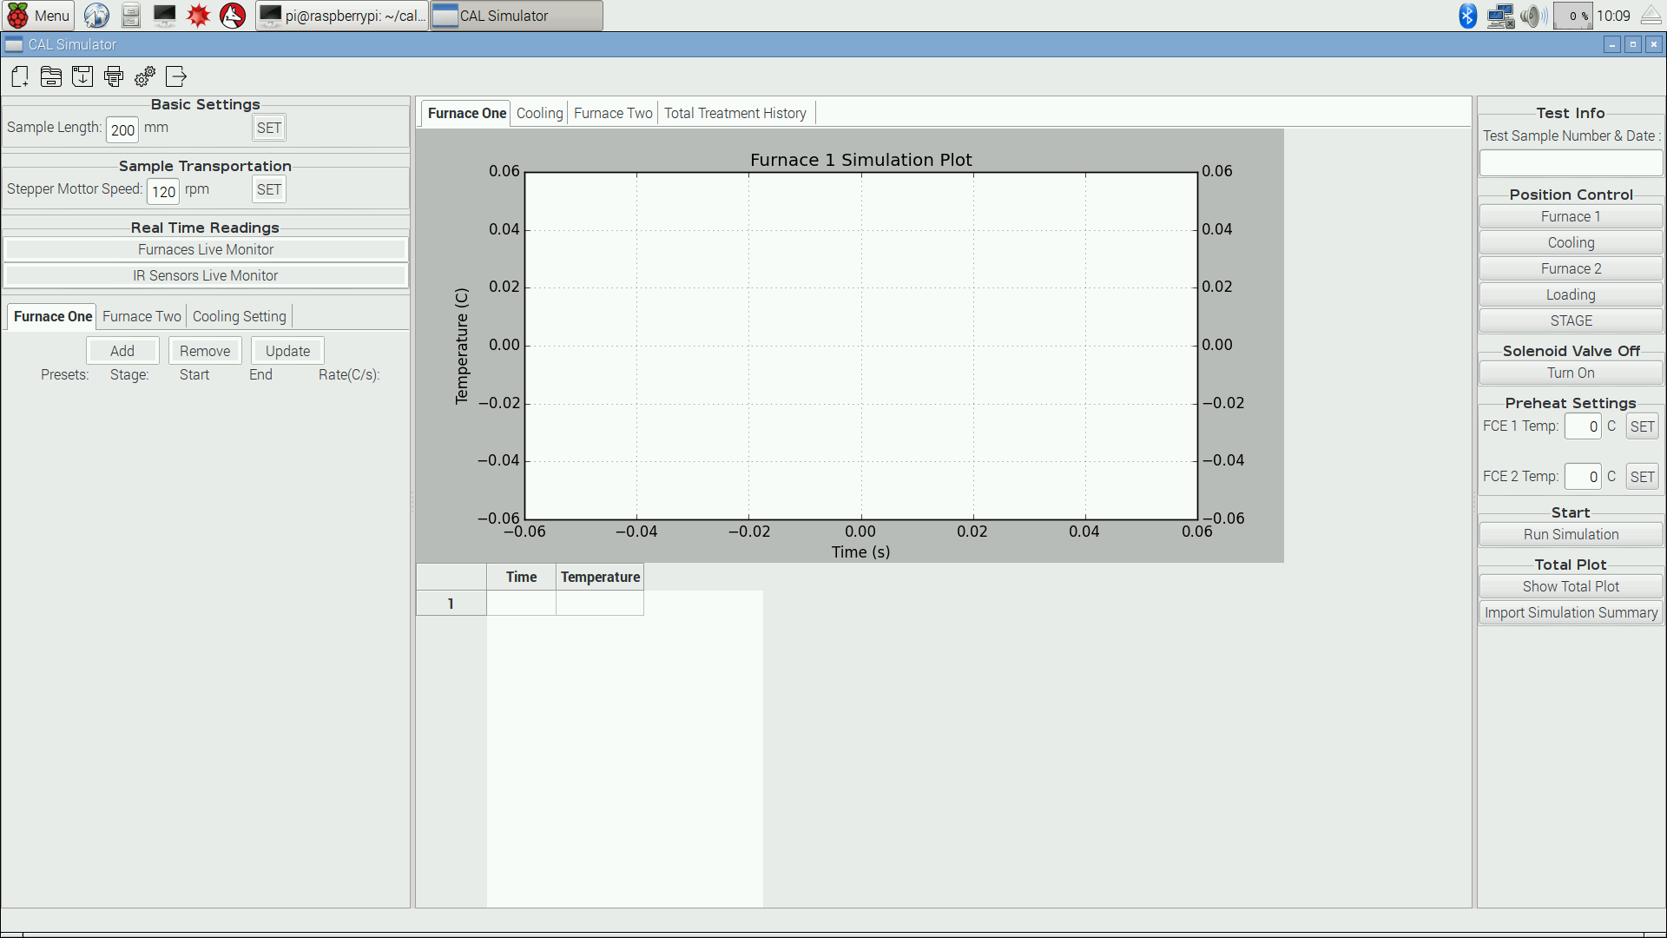

1. Add a set point to the display by clicking the “Add” button (the figure below shows multiple set-points in the leftmost panel) It is important to include a valid test sample name like the one shown in the upper part of the rightmost panel.

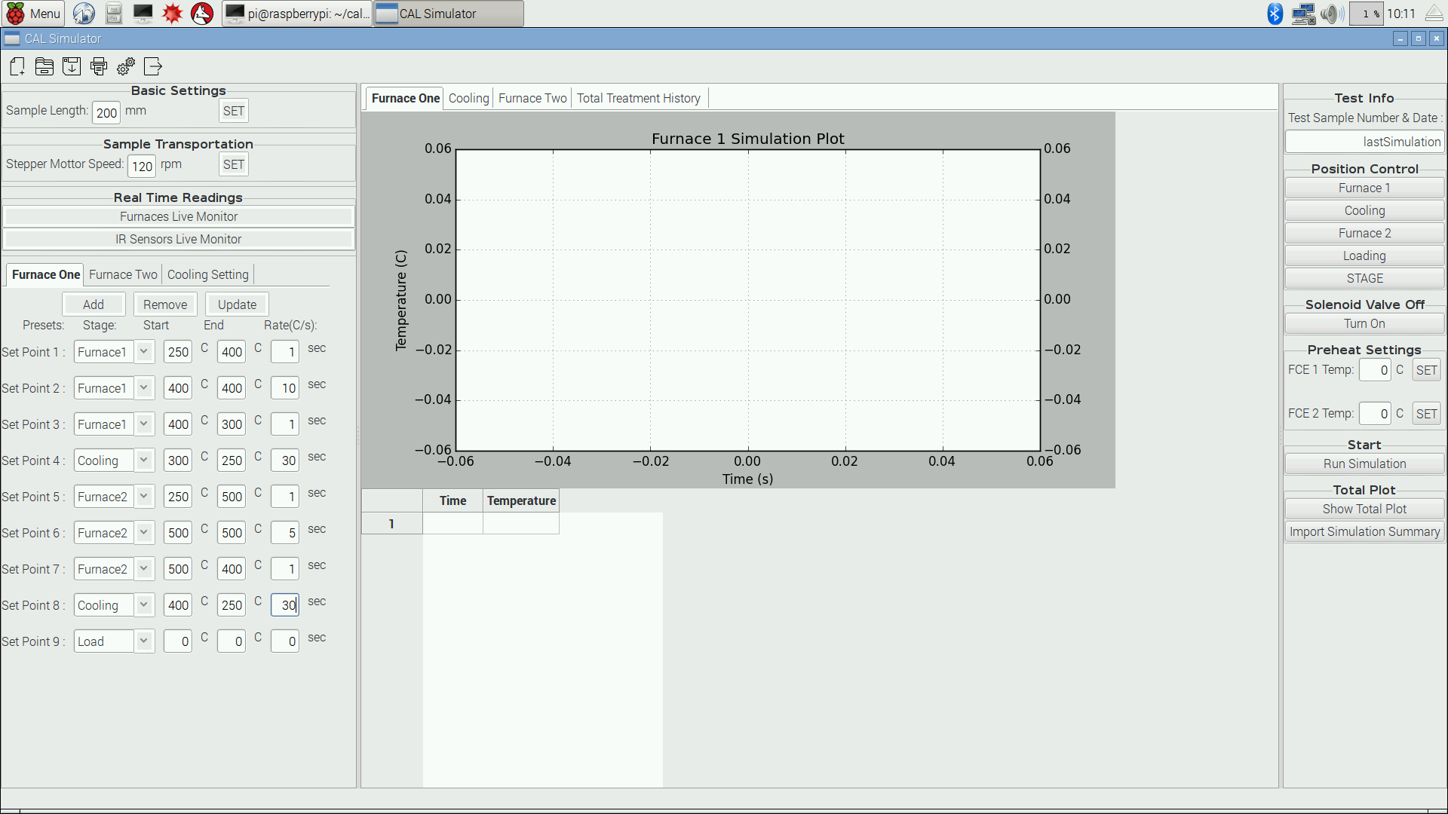

1. The setpoint has 4 components of each one: (Note: Loading is unnaffected by any of the setpoint values)
   1. Stage - i.e. Furnace 1 (Heating), Cooling, Furnace 2 (Reheating) and Loading (Staging and Un-staging)
   2. Start temperature - this has three uses (1) the temperature you would like to heat the sample during the set-point cycle (2) the temperature you would like the sample to be before cooling (3) the temperature you would like to hold the sample at
   3. End temperature - this also has three uses (1) the temperature you would like the sample to ramp up to (2) the temperature you would like the sample to ramp down to (3) the temperature you would like to hold the sample at
   4. Rate - this also has a specific purpose depending on the stage you choose:
      1. Furnace 1 and 2 when start and end temperatures are equal - this rate signifies the length of time the sample will be held in the furnace at a given temperature.
      2. Furnace 1 and 2 when start and end temperatures are not equal - this rate signifies the rates for up ramping and down ramping the furnaces to the desired temperature
      3. Cooling - the rate signifies the rate that the IR sensor in the cooling region will collect data on the sample.
      4. Loading - the rate has no effect
2. An example of an average sample usage with the current simulator is shown in the Figure below:

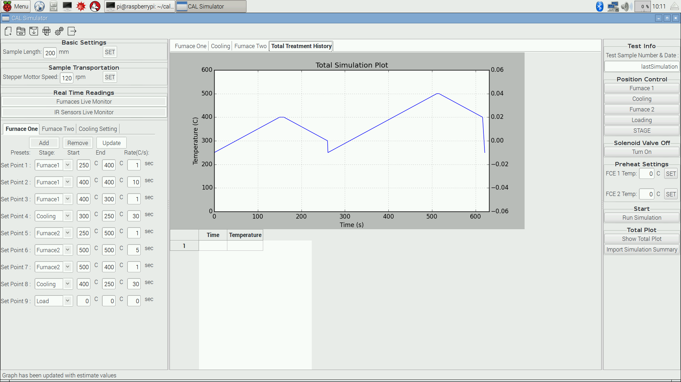

1. Click the “Run Simulation” button to execute the simulation cycle. For example from the above figure.
   1. The sample will travel to Furnace 1 and ramp up from 250 degrees Celsius to 400 degrees Celsius.
   2. When Furnace 1 reaches 400 degrees Celsius it will move to the next set-point and hold the sample at 400 degrees Celsius for 10 seconds.
   3. After the 10 second hold time the simulation will move into the next set-point and ramp the temperature of the sample down to 300 degrees Celsius from 400 degrees.
   4. After the ramp down the next set-point will move the sample to the Cooling Area and cooled from the 300 degree Celsius temperature to the 250 degree Celsius temperature.
   5. After the cooling process a secondary heat treatment shall occur as specified sending the sample to Furnace 2. In Furnace 2 the sample will be ramped up to 500 degrees Celsius from 250 degrees Celsius that the Cooling Stage brought the sample too.
   6. After the in 500 degree Celsius ramp up the sample will then move the next set-point and be held at 500 degrees Celsius temperature for 5 seconds.
   7. After the hold the next set-point will occur and the sample will be ramped down from the 500 degrees Celsius set-point to 400 degrees Celsius.
   8. The next set-point will move the sample to the Cooling Area to be cooled from 400 degrees Celsius to the 250 degree Celsius end temperature
   9. Finally the sample will return to the Load position at the bottom of the simulators to let sit and cooled completely to room temperature before being removed.
2. If you keep the total plot tab opened during simulation you can see the data being plotted live onto the graph. Data is collected for each set-point that you specify in the cycle. You can see the actual numerical data being tabulated below the graph on completion of the simulation. Data is collected for the three different stages as well as the total plot. The three plotted stages are for the Furnace 1 heating cycles, the Cooling cycles, and the Furnace 2 reheating cycles.
3. Plots from prior simulations can be loaded into the graph segments by using the “Show Total Plot” button and selecting the appropriate simulation name and date from the /results folder. These files are saved based on the simulation name that you specify. This format is in the form <simulation_name>-[<date_of_simulation>]-Total.csv. Plots and data for each cycle are calculated and are outputted in similarly formatted files ending with *-Heating.csv, *-Cooling.csv, and *-Reheating.csv.
4. Previous simulation and set-point specifications can be accessed and loaded with the use of the “Import Simulation Summary” button. This will load set-points of a specific summary saved in a file. (Note: If you forget to name your simulation upon running a simulation the data and simulation summary will be saved in a file called lastSimulation-[<date-of-simulation>]-Summary.csv)
5. The rightmost panel labeled “Position Controls” contains controls that allow the position to be moved into various stages of the cycle. (Note: STAGE is important for adding samples of differing size to be simulated and positioned accordingly)
6. The rightmost panel also contains the manual control for the cooling valve, which is located under the section labeled “Solenoid Valve Control”.
7. The “Live Readings” section in the leftmost panel are currently under construction and do not display properly. These are intended to provide the user with live data readings of various sensors of the simulator. This does not work properly due to a need for both furnaces to be on during simulation which is not always optimal for the simulation you would like to run.

# Maintenance

Describe in detail, how to maintain the system. The concern here is what parts of the system are repairable, replaceable, and/or must be calibrated. Since software does not “wear out”, what should be addressed here with respect to software is maintenance of the system in the event of technological changes or changes in hardware platform.

When starting the simulator, you should always start the simulator user interface with the sample in the loading position. If the sample is not in the loading position move it to the position and hit the “Loading” button under “Position Controls” twice.

When starting the simulator initially with the sample at the bottom you must first make sure the stepper motor wheel at the top of the simulator is fully wound making the strip carrying the sample tight. This is important for accurate positioning of the sample in the simulator. After starting the simulator and its components start the GUI and place the appropriate sample input into the GUI “Sample Length” section. After setting the proper sample length hit the “STAGE” button to move the sample into a ready position for simulation. From this point you can run a custom or loaded simulation summary as usual.

# Summary

The CAL simulator is important for providing a good understanding of the annealing process and structures that can be produced within the advanced high strength steel spectrum. The simulations and tests run will increase the production of cheaper and safer materials that can be used in the automotive industry. The hopes of our project improvements was to provide a functional control system that provides more dynamic control of their simulation. A more flexible simulation allows for more research options in how to produce desired microstructures in AHSS materials. The project resulted in the gate above the second furnace operating as originally designed, and when coupled with the added IR sensor for the second furnace, will allow for a greater usage of the second furnace during simulations; while improving the sample’s position accuracy will enable the system to have precise heating, cooling, and temperature readings of the sample during simulations.

# 

# Appendix A: Image of the CAL System

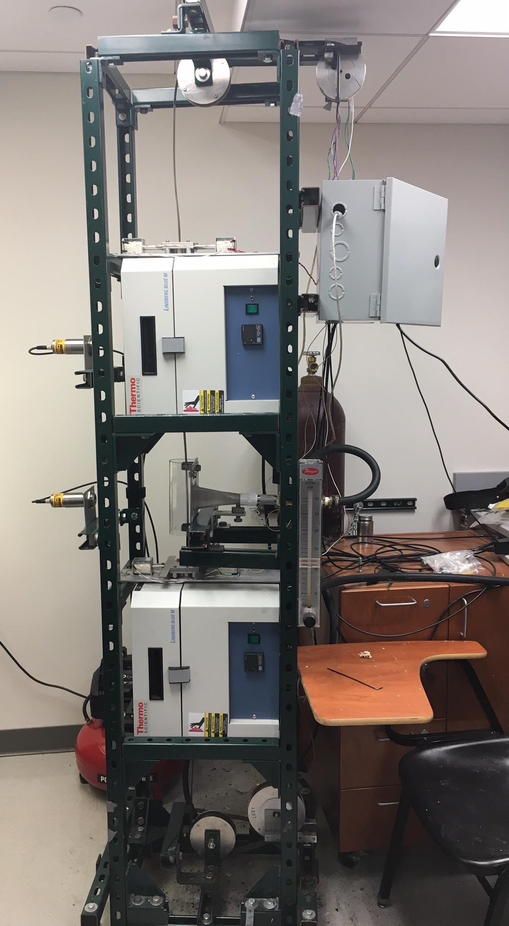CALw/ClosedGate.png

# Appendix B: System Circuit Diagram

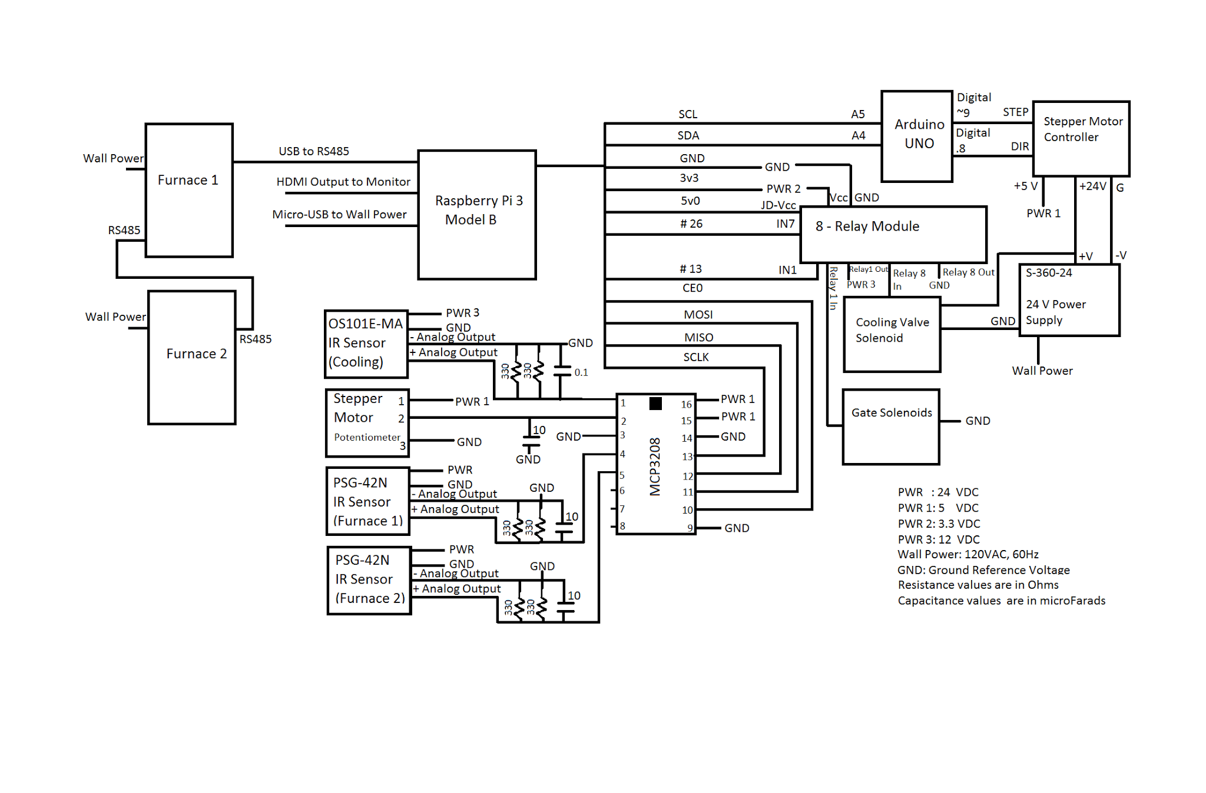

# References

*MCP3208 ADC Datasheet.*<http://www.farnell.com/datasheets/808967.pdf>

*PSG-42N IR Sensor Datasheet*. <http://www.dias-infrared.de/pdf/pyrospot_ds42_dg42_eng.pdf>

*OS101E-MA IR Sensor Datasheet.* <http://www.omega.com/Manuals/manualpdf/M3572A.pdf>

*Lindberg Blue M Furnace User Manual.* <https://www.johnmorrisgroup.com/Content/Attachments/75967/33852-14-22-27.pdf>

*Python Programming Reference.* <https://docs.python.org/2/c-api/>

Other References can be found here: <https://github.com/karatemanz/cal2.0>